|  |  |  |
| --- | --- | --- |
| HCMC UNIVERSITY OF TECHNOLOGY & EDUCATION **FACULTY OF FOREIGN LANGUAGES**  **SECTION: GENERAL ENGLISH & ESP** | | **FINAL TEST ON ENGLISH 2 (ENGL230237)**  TERM III – SCHOOL YEAR: 2014-2015  The paper has 12 pages.  Duration: 60 minutes.  **No materials are allowed.** |
| Invigilator 1’s signature | Invigilator 2’s signature |
| Examiner 1 | Examiner 2 |
| Raw score: | Raw score: |
| **Converted score** | **Converted score** | **Candidate’s name:**  **Student ID No.:**  **Numerical No.:** **Room:** |
|  |  |

**Hướng dẫn đánh trắc nghiệm:**

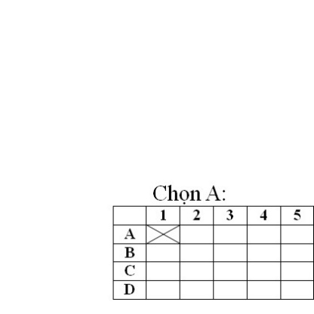 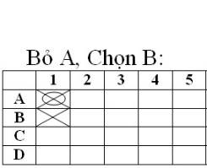 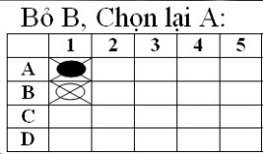

**ANSWER SHEET**

|  |  |  |  |  |  |  |  |  |  |  |  |  |  |  |  |  |  |  |  |  |
| --- | --- | --- | --- | --- | --- | --- | --- | --- | --- | --- | --- | --- | --- | --- | --- | --- | --- | --- | --- | --- |
|  | **1** | **2** | **3** | **4** | **5** | **6** | **7** | **8** | **9** | **10** | **11** | **12** | **13** | **14** | **15** | **16** | **17** | **18** | **19** | **20** |
| **A** |  |  |  |  |  |  |  |  |  |  |  |  |  |  |  |  |  |  |  |  |
| **B** |  |  |  |  |  |  |  |  |  |  |  |  |  |  |  |  |  |  |  |  |
| **C** |  |  |  |  |  |  |  |  |  |  |  |  |  |  |  |  |  |  |  |  |
| **D** |  |  |  |  |  |  |  |  |  |  |  |  |  |  |  |  |  |  |  |  |

|  |  |  |  |  |  |  |  |  |  |  |  |  |  |  |  |  |  |  |  |  |
| --- | --- | --- | --- | --- | --- | --- | --- | --- | --- | --- | --- | --- | --- | --- | --- | --- | --- | --- | --- | --- |
|  | **21** | **22** | **23** | **24** | **25** | **26** | **27** | **28** | **29** | **30** | **31** | **32** | **33** | **34** | **35** | **36** | **37** | **38** | **39** | **40** |
| **A** |  |  |  |  |  |  |  |  |  |  |  |  |  |  |  |  |  |  |  |  |
| **B** |  |  |  |  |  |  |  |  |  |  |  |  |  |  |  |  |  |  |  |  |
| **C** |  |  |  |  |  |  |  |  |  |  |  |  |  |  |  |  |  |  |  |  |
| **D** |  |  |  |  |  |  |  |  |  |  |  |  |  |  |  |  |  |  |  |  |

|  |  |  |  |  |  |  |  |  |  |  |  |  |  |  |  |  |  |  |  |  |
| --- | --- | --- | --- | --- | --- | --- | --- | --- | --- | --- | --- | --- | --- | --- | --- | --- | --- | --- | --- | --- |
|  | **41** | **42** | **43** | **44** | **45** | **46** | **47** | **48** | **49** | **50** | **51** | **52** | **53** | **54** | **55** | **56** | **57** | **58** | **59** | **60** |
| **A** |  |  |  |  |  |  |  |  |  |  |  |  |  |  |  |  |  |  |  |  |
| **B** |  |  |  |  |  |  |  |  |  |  |  |  |  |  |  |  |  |  |  |  |
| **C** |  |  |  |  |  |  |  |  |  |  |  |  |  |  |  |  |  |  |  |  |
| **D** |  |  |  |  |  |  |  |  |  |  |  |  |  |  |  |  |  |  |  |  |

**PART 1: INCOMPLETE SENTENCES**

**There are 24 questions in this part.**

***Directions: A word or phrase is missing in each of the sentences below. Four answer choices are given below each sentence. Select the best answer to complete the sentence. Then mark the letter (A), (B), (C), or (D) on your* ANSWER SHEET*.***

**Questions 1:** Defining the skyline of Ho Chi Minh City, the Bitexco _____________stands right at the heart of the city’s Central Business District.

**A.** stadium **B.** subway system **C.** skyscraper **D.** plaza

**Question 2:** _________ is a large area of land where it is always very dry and there is a lot of sand.

**A.** Rain forest **B.** Desert **C.** River **D.** Waterfall

**Question 3:** Experience can help you communicate _________ than having much knowledge.

**A.** skillfully **B.** the mostskillfully **C.** mostskillfully **D.** moreskillfully

**Question 4:** I am going to ask you something and I want you to be _________with me.

**A.** reliable **B.** mature **C.** honest **D.** decisive

**Question 5:** My train at 6 o’clock this Friday night, and I my family after that.

**A.** is arriving / am meeting **B.** arrives / meet

**C.** arrives / am meeting **D.** will arrive / have met

**Question 6:** Mr. Henry said the network system will be _________ operational by January.

**A.** completion **B.** complete **C.** completing **D.** completely

**Question 7:** Mr. James Le is intensely__________, obsessed with the idea of becoming rich.

1. ambitious **B.** outgoing **C.** adventurous **D.** curious

**Question 8:** The cost of living in this country _________by 17 percent over the last 15 years.

**A.** will rise **B.** has risen **C.** rising **D.** rise

**Question 9:** If an applicant’s résumé passes the resume screen, the ___________is usually the next major step in the pre-employment screening process.

1. job interview **B.** conference call **C.** business meeting **D.** soccer practice

**Question 10:** Customers offer _________advice on our new product lines.

**A.** construct **B.** constructive **C.** constructs **D.** constructively

**Question 11:** It was very ________of you to let us know you were going to be late.

**A.** curious **B.** patient **C.** considerable **D.** considerate

**Question 12:** Tony has been totally unreliable ___________he started the new job.

**A.** when **B.** since **C.** for **D.** while

**Question 13** Manchester United has to win every game at Old Trafford________ next season to compete for title.  
**A.** tunnel **B.** bridge **C.** plaza **D.** stadium

**Question 14:** Just as true love has to surpass several obstacles; the_________ of Love in Dalat had to surpass many challenges in the past in order to gain its rightful name today.

**A.** Waterfall **B.** Islands **C.** Valley **D.** Lake

**Question 15:** You should not do other people’s works because this can _______a lot of time.

**A.** take up **B.** take off **C.** take away **D.** take back

**Question 16:** Our new car is attractive to familiar with children.

**A.** extreme **B.** extremely **C.** extremity **D.** extremes

**Question 17:** More_______ visitors can go skiing or snowboarding.

**A.** easy-going **B.** stubborn **C.** adventurous **D.** optimistic

**Question 18:** Due to the _________ conditions, the company made a lot of money.

**A.** economy **B.** economic **C.** economist **D.** economically

**Question 19:** What’s ________way to travel around this city?

**A.** good **B.** better **C.** best **D.** the best

**Question 20:** Mary: How many people live in Manhattan of the Desert?

Paul: _________

**A.** I don’t believe it!

**B.** I don’t have a clue.

**C.** It’s more than 2000 years old.

**D.** The largest desert in Asia.

**Question 21:** Roberto: Hello! Could I speak to Jennifer?

Rose: Um, sorry. Jennifer’s is busy right now. ____________________?

**A.** Why do you say that

**B.** Do you want to leave a message

**C.** Would you tell him know

**D.** Don’t you think so?

**Question 22:** Emelia: Would you mind giving me a ride to work?

Jessica: ________________________________________

**A.** No problem. I’ll pick you up at 9.00.

**B.** Ok. I’ll do that. What does he eat?

**C.** Uh, sure. This is Rex Hanson.

**D.** I don’t mind. I’ll feed them after work.

**Question 23:** Terry: Maybe it’s just me, but I think “Practice makes perfect”.____________________

Gerrard: I’m not sure. Why do you say that?

**A.** Why do you say that?

**B.** Seriously?

**C.** You’re kidding.

D. Don’t you think that true?

**Question 24:** Steve: I’m broke. Could you please_________________?

John: Sure.

**A.** get my mail

**B.** lend me some money

**C.** give me a ride

**D.** pick me up

**PART 2: INCOMPLETE TEXTS**

**There are 6 questions in this part.**

***Directions: Read the texts below. A word or phrase is missing in some of the sentences. Four answer choices are given below each of these sentences. Select the best answer to complete the text. Then mark the letter (A), (B), (C), or (D) on your* ANSWER SHEET*.***

**Questions 25 through 27 refer to the following information.**

|  |
| --- |
| As of January 1st of next year all students will be able to (25)_________the library academic research databases by using their student ID numbers and a password that will be provided by the library staff. This is a change from the former policy that only allowed graduate and post-graduate students to use the databases. This new policy is possible because of the huge grant that the library (26) __________ last year from the Gaetz Foundation which honors our former university president, Gilbert Gaetz. Students who do not know how to use database system will be able to sign up for free tutorial sessions (27) ________ in December of this year. |

**Question 25: A.** approach **B.** access **C.** close **D.** accept

**Question 26: A.** receive **B.** receiving **C.** received **D. to** receive

**Question 27: A.** of **B.** as **C.** during **D.** starting

**Questions 28 through 30 refer to the following passages.**

|  |
| --- |
| **ITC** is one of the first companies to realize commercial (28) ______ of laser light. Our lasers (29)_______by hospitals for delicate surgery and in factories to cut textiles and to harden metals. ICT lasers read prices in the supermarkets and play compact discs in homes. They help scientists (30)_________distances in outer space and school children to learn basic science skills. ITC, bringing the future to you. |

**Question 28: A.** apply **B.** to apply **C.** applying **D.** applications

**Question 29: A.** use **B.** used **C.** are used **D.** are using

**Question 30: A.** measured **B.** measurement **C.** to measure **D.** measures

**PART 3: READING COMPREHENSION**

**There are 30 questions in this part.**

***Directions :* In this part of the test, you will read a selection of texts, such as magazine and newspaper articles, letters and advertisements. Each text is followed by several questions. Choose the correct answer to each question and mark the letter (A), (B), (C), or (D) on your answer sheet.**

**Questions 31 through 33 refer to the following advertisement.**

|  |
| --- |
| **Central Vision Movie Theater**  **Please note that the new Saturday schedule is different than that printed in this week’s Weekly Herald.**  **Update showings for Saturday:**  1:00 p.m. *Monsoon Wedding*  3:00 p.m. *The Rugrats*  5:00 p.m. *The Man in Black*  7:00 p.m. *Monsoon Wedding*  9:00 p.m. *Friday the 13th*  All shows before 5:00 p.m. have the matinee price of $3.00. All shows after 5.00 p.m. cost $7.00. Children and Senior Citizens pay only $2.00 for any show of the day. Check out our special family tickets, too : two adults and three children can watch any matinee for only $10.00. Our food counters serve a wide range of hot and cold drinks, and popcorn and refreshments are served during all movies. Please put your trash in the trash bins at the end of the movie. |

**Question 31:** How much do children pay for movies before 5:00 p.m.?

**A.** $3.00

**B.** $7.00

**C.** $5.00

**D.** $2.00

**Question 32:** Which movie has two showings on Saturday**?**

**A.** *Monsoon Wedding*

**B.** *The Rugrats*

**C.** *The Man in Black*

**D** *Friday the 13th*

**Question 33:** How much do adults pay after 5:00 p.m.**?**

**A.** $3.00

**B.** $7.00

**C.** $5.00

**D.** $2.00

**Questions 34 through 38 refer to the following text.**

Every year students in many countries learn English. Some of these students are young people, others are teenagers. Many are adults. Some learn at school, others study themselves. A few learn English just by hearing the language in film on television, in the office or among their friends. But not many are lucky enough to do that. Most people must work hard to learn another language. Many boys and girls earn English at school because it is one of their subjects. They study their own language, mathematics and English. In England, or America, or Australia, many boys and girls study their own language, which is English, and mathematics and another language, perhaps French, or German or Spanish. Many adults learn English, because it is useful for their work. Teenagers often learn English for their higher studies, because some of their books are in English at college or university. Others people learn English because they want to read newspapers or magazines in English.

**Question 34:** **According to the writer:**

**A.** No children like learning English.

**B.** English is useful only to teenagers.

**C.**  Only adults learn English.

**D.** English is popular in much of the world.

**Question 35:** **Many people learn English by**:

**A.** Watching videos only.

**B.** Talking with the film stars.

**C.** Hearing the language in office.

**D.** Working hard on their lessons.

**Question 36:** **In America or Australia many school children study**

**A.** English as a foreign language.

**B.** English and mathematics only.

**C.** Such foreign languages as French, German and Spanish.

**D.** Their own language and no foreign language.

**Question 37:** **Many adults learn English because:**

**A.** They want to go abroad.

**B.** Their work is useful.

**C.** Most of their nooks are in English.

**D.** It helps them in their work.

**Questions 38 through 40 refer to the following text.**

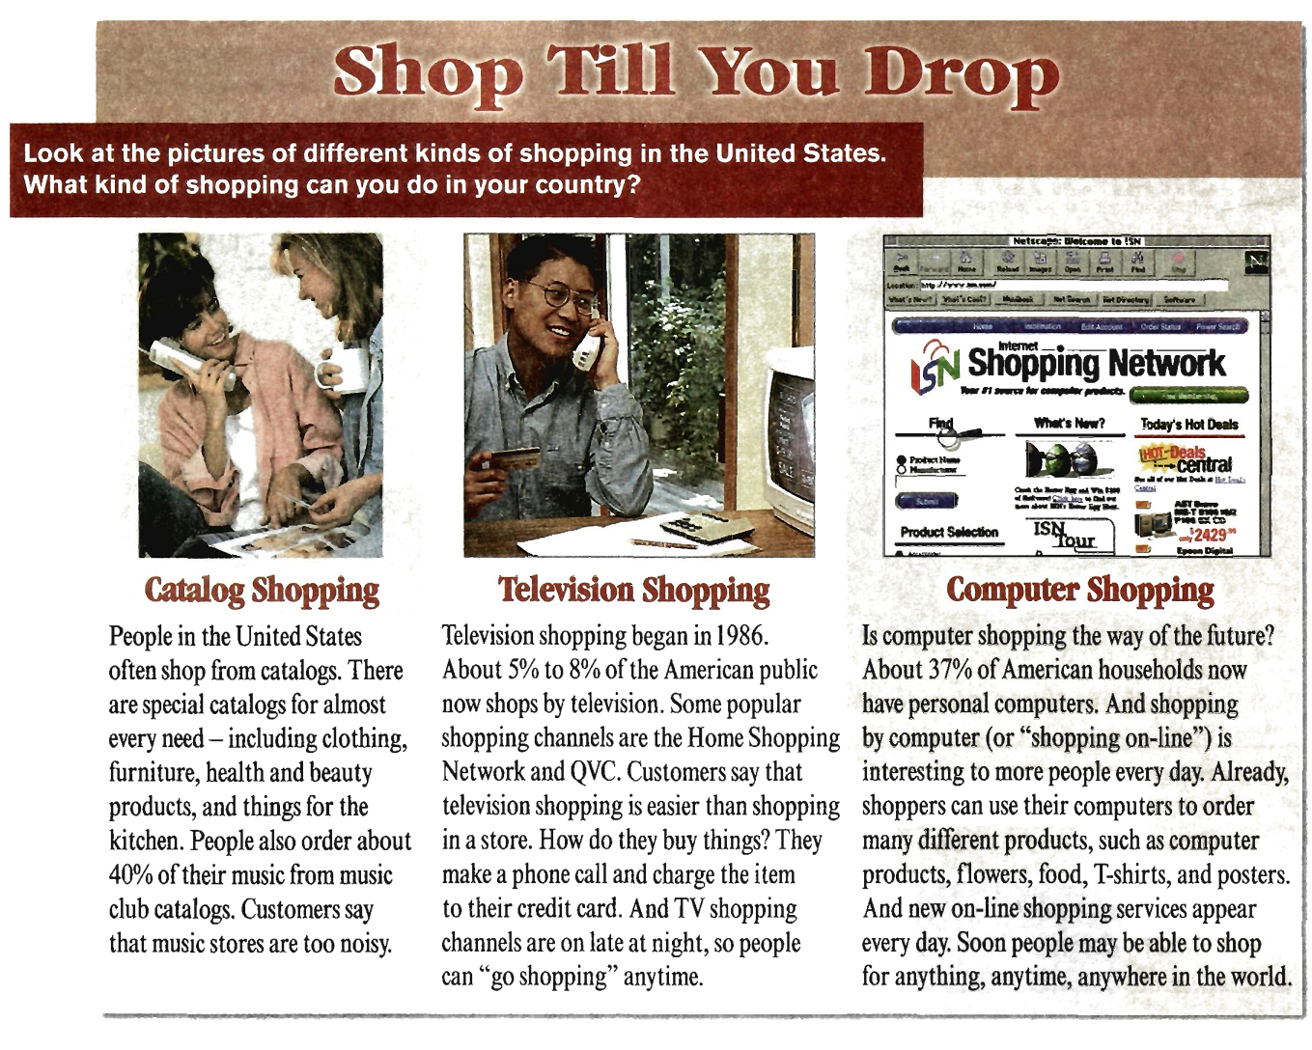

**Question 38:** What is NOT mentioned on catalogs that American people often shop?

**A.** Clothing

**B.** Furniture

**C.** Television

**D.** Beauty products

**Question 39:** How do customers think about television shopping?

**A.** It is easier than shopping in a store.

**B.** It is too noisy.

**C.** It is more difficult than computer shopping.

**D.** It is extremely limited.

**Question 40:** **How many percent of American households now have personal computers?**

**A.** 40%

**B.** 5% to 8%

C. 58%

**D.** 37 %

**Questions 41 through 44 refer to the following text**

|  |
| --- |
| For many years people believed that the cleverest animals after man were chimpanzees. Now, however, there is proof that dolphins may be even clever than these big apes.  Although a dolphin lives in the sea, it is not a fish. It is a mammal. It is many ways, therefore, like a human being.  Dolphins have a simple language. They are able to talk to one another. It may be possible for man to learn how to talk to dolphins. But this will not be easy because dolphins cannot hear the kind of sounds man can make. If man wants to talk to dolphin, therefore, he will have to make a third language which both he and dolphins can understand.  Dolphins are also very friendly towards man. They often follow ships. There are many stories of dolphins guiding ships through difficult and dangerous waters. |

**Question 41:** Which animals do people think may be the cleverest?

**A.** Mammals

**B.** Dolphins

**C.** Big apes

**D.** Chimpanzees

**Question 42:** What other beings are dolphins like in many ways?

**A.** Fish

**B.** Men

**C.** Animals

**D.** Reptiles

**Question 43:** What have scientists discovered about dolphins?

**A.** Man can now talk to them.

**B.** They understand simple language.

**C.** They can speak to one another.

**D.** They can teach men their languages.

**Question 44:** Why is a third language necessary if man wants to talk to dolphins?

**A.** The dolphins’ language is hard to learn.

**B.** Dolphins cannot hear men speaking.

**C.** Most men do not speak English.

**D.** Men want to talk to dolphins in secret.

**Questions 45 through 47 refer to the following article**

|  |
| --- |
| Jason Avery has been a professional comedian for over fifteen years. As he says, “It is not easy to make people laugh every night. As a comedian, you have to keep inventing new jokes all the time to keep the public happy.” Obviously, Mr. Avery has been very successful doing this. He has appeared on many popular television shows and has been a guest of the President at special ceremonies. Avery’s most recent works, in addition to television shows, has been several popular movies and cable broadcast comedy programs. He also frequently donates his time to charity events to help raise money for children in need. The most rewarding part of his job. Avery said, is to see people smile. As Avery says, “It’s hard job, but someone has to do it!” |

**Question 45:** What is Avery’s occupation?

**A.** Actor

**B.** Broadcaster

**C.** Comedian

**D.** Donor

**Question 46:** Who benefits from Avery’s charity performances?

**A.** Politicians

**B.** Senior citizens

**C.** Acting students

**D.** Children.

**Question 47:** What does Avery like best about his job?

**A.** Helping others

**B.** Seeing people smile

**C.** Being famous

**D.** Meeting the President

**Questions 48 through 50 refer to the following text.**

|  |
| --- |
| An artist went to a beautiful part of the country for a holiday, stayed with a farmer. Every day he went out with his paints and his brushes and painted from morning to evening, and when it got dark, we went back to the farm and had a good dinner before going to bed. At the end of his holiday, he wanted to pay the farmer, but the farmer said: “No, I don’t want money, but give me one of your pictures. What is money? In a week, it will all be finished, but your painting will be here”. The artist was very pleased and thanked the famer for saying such kind things about the paintings. The farmer smiled and answered: “It is not that. I have a son in London. He wants to become an artist. When he comes here next month, I will show him a picture, and then he will not want to be an artist any more, I think”. |

**Question 48:** What did the artist do during his holiday?

**A.** He made paints and brushes.

**B.** He went back to the farm.

**C.** He painted all day.

**D.** He went out every day.

**Question 49:** Why was the artist very pleased with the farmer’s request?

**A.** Because he had so many kinds of pictures.

**B.** Because he would sell one of his pictures.

**C.** Because the farmer had thanked him.

**D.** Because he thought his pictures were so beautiful.

**Question 50:** The farmer’ son didn’t want to become an artist anymore

**A.** When he came here.

**B.** Because he had the artist’s picture.

**C.** Because he lived in London.

**D.** After he had seen the artist’s picture.

**Questions 51 through 53 refer to the following text**

|  |
| --- |
| This year, the Department of Education will allow all students to renew their loans online through our department website. To complete this process you will need to have a personal identification number (PIN), which you will use to access your personal account information. If you do not already have a PIN, you can establish one by going to the website and entering your last name and social security number. After that, you will be allowed to select your own PIN or let our computer generate one for you. Be sure to write down your PIN, as you will need it for all future use on the website. This PIN can be used year after year. There is no need to create a new PIN next year once you made on this year. The estimated time to create a PIN is about five minutes. |

**Question 51:** Who is this information directed toward?

A. Social workers

**B.** Teachers

**C.** Politicians

**D.** Students

**Question 52:** What do you need to access account information?

**A.** A personal identification number

**B.** Five minutes of computer time

**C.** Online education

**D.** A code word

**Question 53:** What do you need to create a PIN if you do not have one?

**A.** Your student ID number

**B.** Your last name

**C.** Your phone number

**D.** Your first name

**Questions 54 through 56 refer to the following text**

|  |
| --- |
| Lynn Hurley is in the news again, but this time not for her acting. The 32-year-old movie star was caught shoplifting from a fancy downtown department store.  Security guards stopped Ms. Hurley at the doors of a well-known department store with over $1,200 of jewelry in her purse. Officials are investigating the case and trying to decide if Ms. Hurley was only stealing for fun or if she really needed the jewelry for her next movie. Bail was set at $2,500 for the release of Ms. Hurley, but so far her family refused to pay. If convicted of crime, the actress could be subject to a fine of $10,000 or one month in jail. |

**Question 54:** What is Ms. Hurley’s profession?

**A.** Reporter

**B.** Police officer

**C.** Homemaker

**D.** Actress

**Question 55:** How much is bail for the release of Ms. Hurley?

**A.** $10,000

**B.** $ 2,500

**C.** $1,200

**D.** $ 100,000

**Question 56:** What did probably Ms. Hurley steal?

**A.** A necklace

**B.** A purse

**C.** A scarf

**D.** Money

**Questions 57 through 60 refer to the following letter.**

|  |
| --- |
| Reading to oneself is a modern activity which was almost unknown to the scholar of the classical words while during the 15 century the term “reading” undoubtedly meant reading aloud. Only during the 19 century did silent reading become commonplace.  One should be wary, however, of assuming that silent reading came about simply because reading aloud is a distraction to others. Examination of factors related to the historical development of silent reading reveals that it became the usual mode of reading for most adults reading tasks mainly because the tasks themselves changed in character.  The last century saw a steady gradual increase in literacy and thus in number of readers. As readers increased, so the numbers of potential listeners declined, and thus there was reduction in the need to read aloud. As reading for the benifit of listeners grew less common, so came the flourishing of reading as a private activity in such public places such as libraries, railways carriages and offices where reading aloud would cause distraction to other readers.  Towards the end of the century there was still considerable argument over whether books should be used for information or treated respectfully, and whether the reading of material such as newspapers was in some way mentally weakening. Indeed thais urgument remains with us still in eduacation. However, whatever its virtues, the old shared literacy culture had gone and was replaced by the printed mass media on the one hand and by books and periodicals for specialized readership on the other. |

**Question 57:** Why was reading aloud common before the 19th century?

1. People relied on reading entertainment.
2. Few people could read for themselves.
3. Silent reading had not been discovered.
4. There were few places available for private reading

**Question 58:** The development of silent reading during 19 century indicated

**A.** an increase in the averange of readers.

**B.** a change in the nature of reading.

**C.** a change in the status of reading

**D.** an increase in the number of books.

**Question 59:** Educationalist are still arguing about

**A. the value of diffrent types of reading material.**

**B.** the amount of information yielded by books and newspapers.

**C.** the effects of reading on health.

**D.** the importance of silent reading.

**Question 60:** The emergence of the mass media and of specialised periodicals showed that

**A.** printing techniques had improved.

**B.** readers interests had diversified.

**C.** educationlist attitudes had changed

**D.** standards of literacy had declined.

-----------------------------------------------

----------- THIS IS THE END OF THE TEST ----------

|  |  |
| --- | --- |
| **Chuẩn đầu ra của học phần (về kiến thức)** | **Nội dung kiểm tra** |
| [CĐR 1.1]: Lựa chọn chính xác các thì và cấu trúc cơ bản trong tiếng Anh. | Các câu hỏi 9-19, các câu hỏi 25-30 |
| [CĐR 1.2]: Tái hiện kiến thức cơ bản về phát âm, từ vựng để giao tiếp trong các tình huống cơ bản trong cuộc sống và công việc. | Các câu hỏi 1-8, các câu hỏi 25-30 |
| [CĐR 2.2]: Đọc hiểu các đoạn văn ngắn, mẩu tin ngắn, mẩu quảng cáo | Các câu hỏi 31-60 |
| [CĐR 2.4]: Sử dụng từ vựng và cấu trúc ngôn ngữ phù hợp trong các tình huống giao tiếp khác nhau. | Các câu hỏi 20-24 |

Ngày tháng năm 20

**Thông qua bộ môn**